Charting Progress – template & planning information
Field | Content
Pub date
Draft due
Programme
Title
To be completed several days in advance – discuss with Ian/Andrew first
Field | Content
Brief description/ key message | Total % of humanitarian assistance to NGOs that is channelled through local and national NGOs is falling, as is the percentage of total % HA channelled through all NGO types.
Pub date (draft 2 days before) | 6 August 2015
Author | Sarah/Cat

Field | Content
Title (max 55 characters) | Percentage of humanitarian funding directly channelled through local and national NGOs is low, and falling
Sub title (optional, max 50 characters)

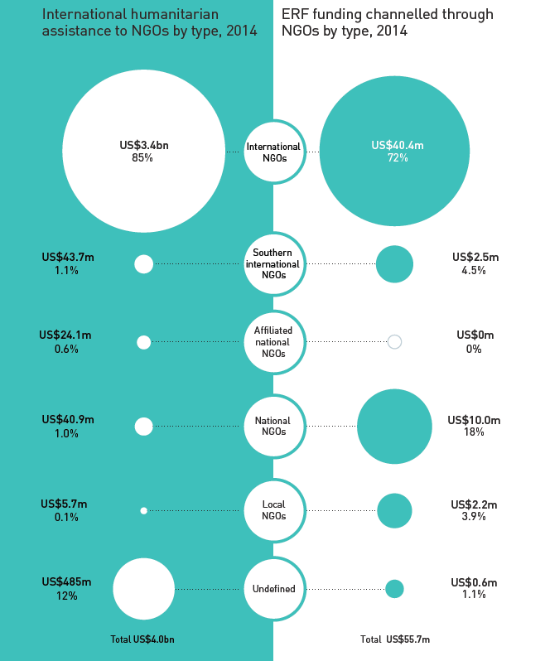

Field | Content
Intro para (summarises key point/message) (max 250 characters) | In 2014, non-governmental organisations (NGOs) received 18% of the total humanitarian funding reported to the UN Office for the Coordination of Humanitarian Affairs (OCHA)’s Financial Tracking Service (FTS).
Body text (max 1,000 characters) | Local and national NGOs together received only US$46.6 million (1.2% of the total given directly to NGOs) in 2014, having declined from a peak of US$58.0 million in 2011. This represents 0.2% of the total humanitarian assistance reported to the FTS in 2014, compared with 0.4% in 2012.  [INSERT INFOGRAPHIC HERE]  The number of local and national NGOs receiving this funding has also dropped – only 16 local NGOs and 80 national NGOs were recorded in the UN OCHA FTS as having received funding in 2014, which is down from 22 and 95, respectively, in 2013. At the same time, the number of international NGOs receiving funding grew – from 300 in 2013 to 339 in 2014.  While emergency response funds (ERFs; country-based pooled funds) were designed to be accessible to local actors, and indeed the majority of ERF funding has been channelled through NGOs over the past five years (57%), only 21.9% of this was channelled through local and national NGOs in 2014.  For more please see our Global Humanitarian Assistance (GHA) Report 2015.
Footnotes | Values are those committed/contributed (constant 2013 prices). Scaled by percentage. For NGO coding methodology , see Data & Guides.
Source | Development Initiatives based on UN OCHA FTS data
Suggested social media activity/ tweet text | READ: Blog > Small % of humanitarian funding is directly channelled through local and national NGOs [LINK]

