|  |  |  |
| --- | --- | --- |
| Briefing paper | | |
| World Bank Annual Meetings | | 2013  October |
| Development Initiatives exists to end absolute poverty by 2030 |
| Description: Description: RGB_logo_sp.eps | [www.devinit.org](http://www.devinit.org) |

## Understanding the resource landscape

A future development financing framework will need to mobilise significant financial resources in innovative ways to ensure a sustainable future for all. We urge the World Bank to consider the entire resource landscape and the various opportunities to mobilise resources in different contexts. In this paper, we highlight that:

* The scale and diversity of international resources has grown rapidly.
* Domestic resources are also growing, but remain low in many developing countries.
* Resources flow both ways – the scale and impact of outflows must be taken into account.
* Official development assistance (ODA) remains vital for countries with the least domestic resource capacity.
* Huge improvements to data and access to information on wider resource flows is critical.

*Further information can be found in our September 2013 report ‘Investments to End Poverty’.*

**The scale and diversity of international resources has grown rapidly**

Large increases in foreign direct investment, remittances and lending have driven increasing volumes of financial resources flowing to developing countries. This presents growing opportunities to harness these flows, although given the different nature of each flow, the policies or instruments to harness their contributions to poverty eradication will vary.

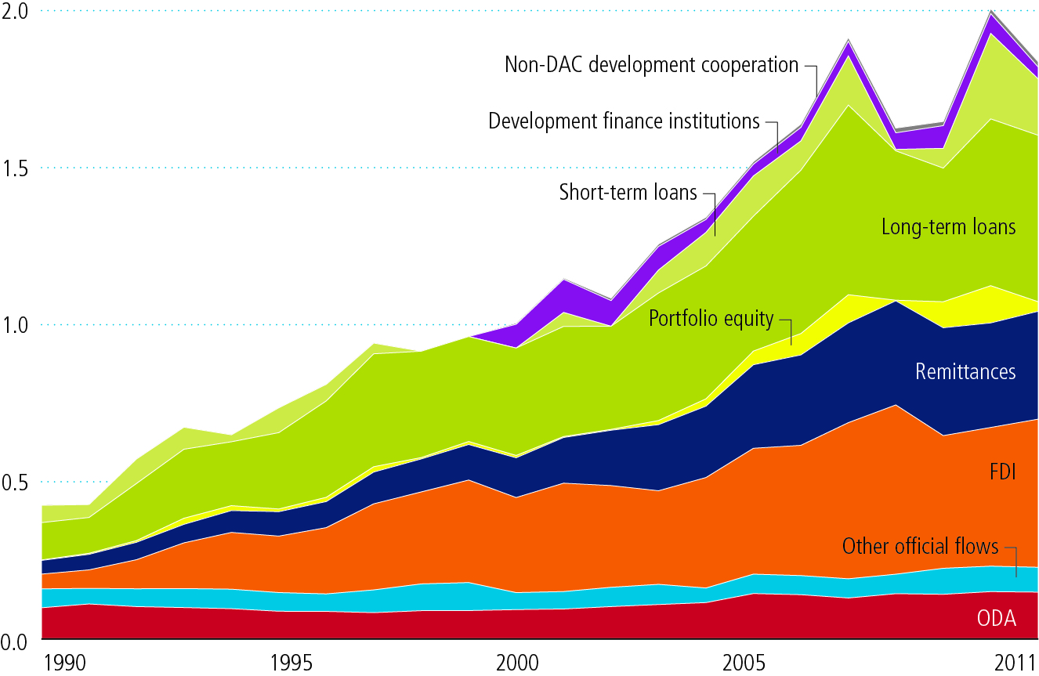

Figure 1: International resource flows to all developing countries ($ trillion). Source: *Investments to End Poverty*

**Resources are flowing both into and out from developing countries**

There are many reasons why resources flow out of developing countries and outflows are not necessarily detrimental to the countries they leave. However, in some cases outflows do reduce the domestic resources available to combat poverty. It is important that the full picture of inflows and outflows of resources is well understood.

**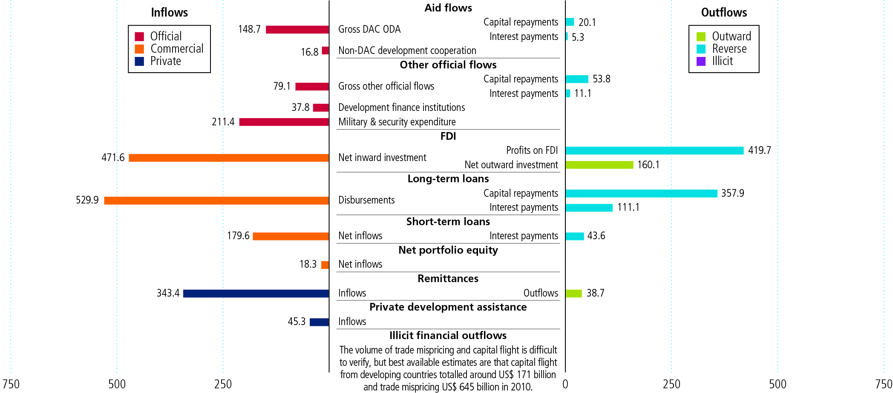**

Figure 2: Inflows and outflows of resources to all developing countries, 2011. Source: *Investments to End Poverty*

**Domestic resources are growing, but remain low in many countries**

More than four-fifths (82%) of people living below $1.25 a day worldwide live in countries where government expenditure is less than PPP$1,000 per person per year. This compares with OECD Development Assistance Committee (DAC) average expenditure of PPP$15,000. Even the most efficient and benevolent governments will face substantial constraints to what can be achieved with such low resource levels.

**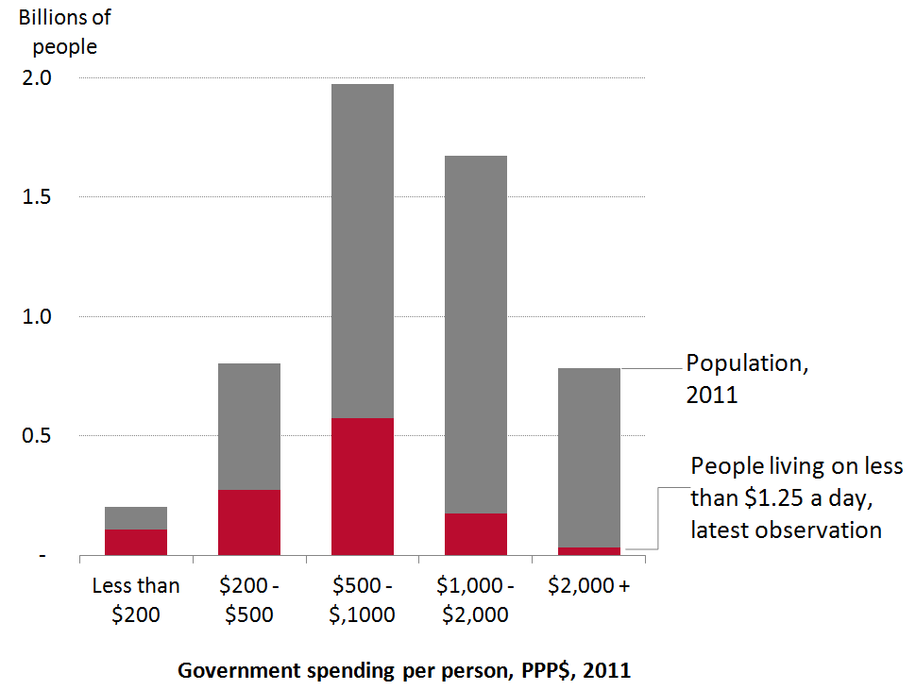**

Figure 3: Population and number of people living in poverty, billions (based on latest estimates). Source: *Investments to End Poverty*

**ODA remains vital for countries with the lowest domestic resource capacity**

Despite rapid growth in wider resource flows, ODA remains the largest resource flow to the poorest countries. ODA is the largest resource received by almost three-quarters of countries where annual government expenditure is less than PPP$500 per person. Remittances are important for countries with large diasporas, and foreign direct investment (FDI) is for countries with slightly higher government spending, and with natural resources.

*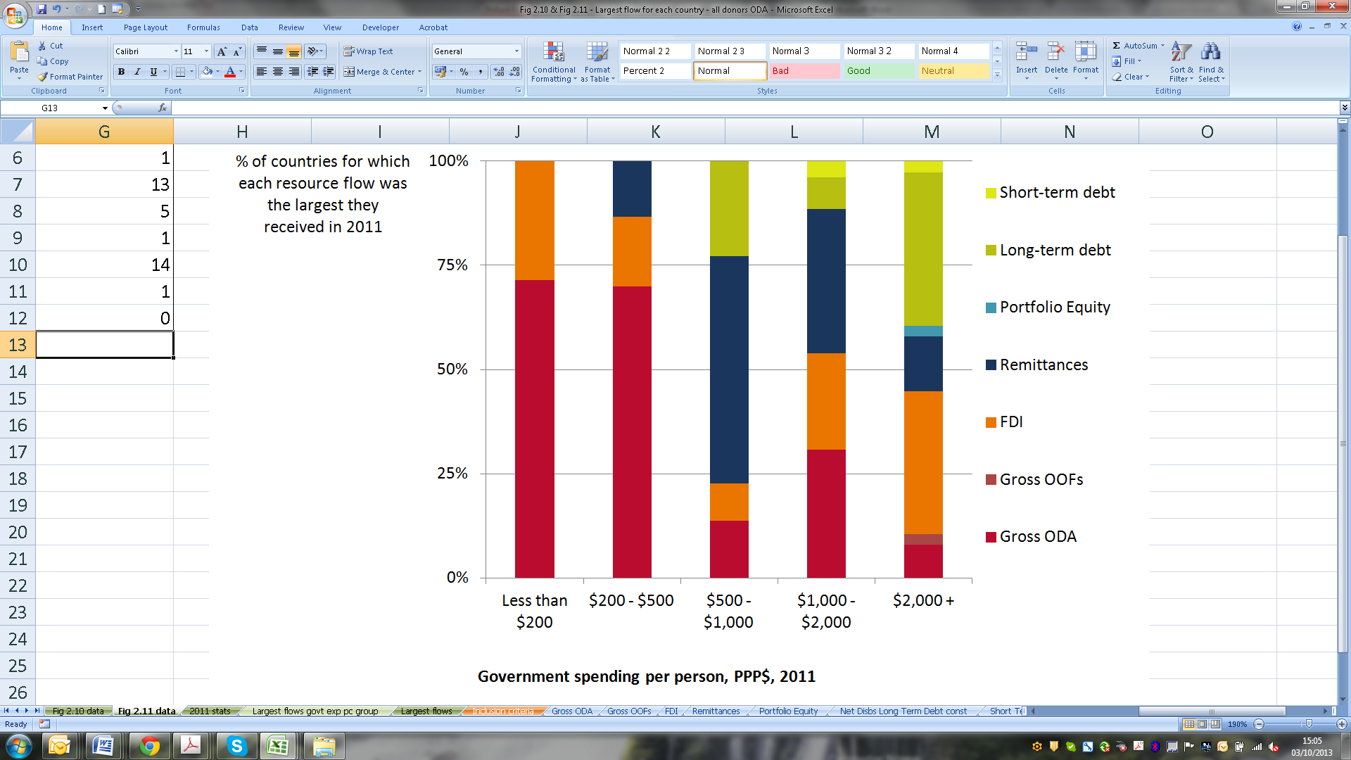*

Figure 4: The proportion of countries for whom each resource flow is the largest, 2011. Source: *Investments to End Poverty*

**Financing will require different strategies in different contexts**

The mix of resources varies considerably by country*.* Ethiopia and Viet Nam both have a significant task ahead to eradicate poverty. Latest estimates show that Ethiopia has 26 million people living below $1.25 a day (2011) and Viet Nam 14 million people (2008). However, the mix of resources to these countries is very different and the financing plan may look very different in each country too. Aid remains a comparatively large resource for Ethiopia while Viet Nam receives significant volumes of other resources – especially remittances and foreign direct investment.

**Ethopia Viet Nam**

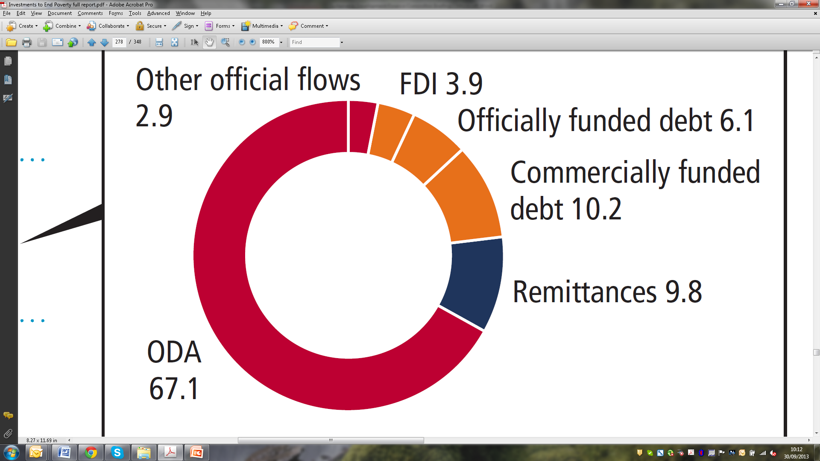**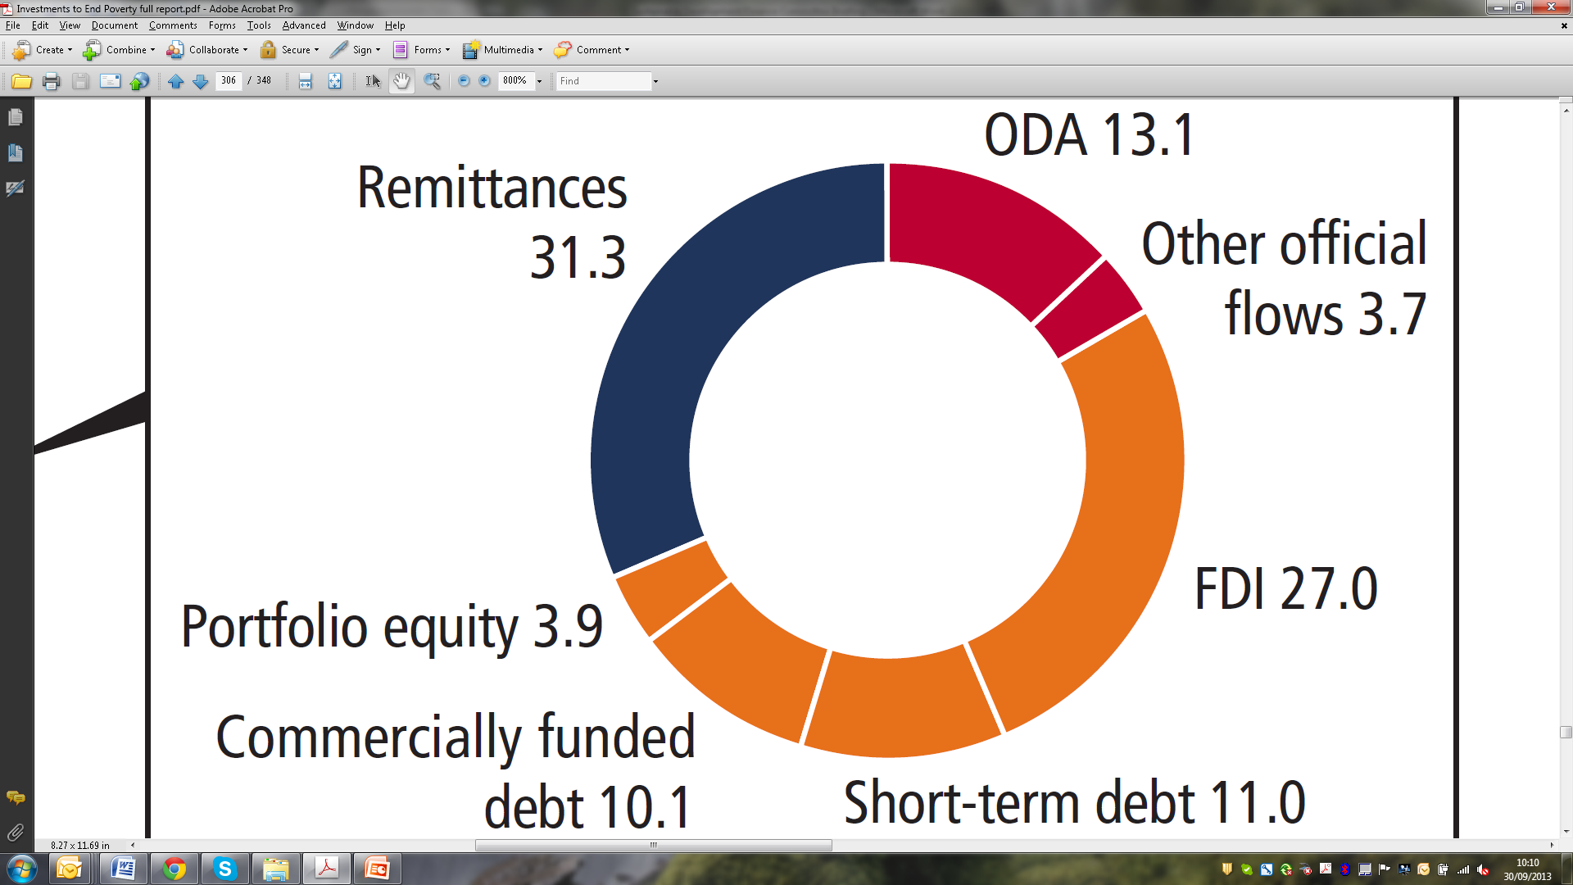**

Figure 5: International resource flows to Ethiopia and Viet Nam, proportion of total received (%). Source: *Investments to End Poverty*

## Huge improvements to data and access to information on wider resource flows is critical

The data that exists on international resource flows can charitably be described as poor. For most resources, data only describe headlines such as total volumes to or from a particular country, and even these estimates are subject to omissions or inconsistencies between sources. We know very little about how resources are spent within countries, the channels of delivery, modalities of finance, the reverse flows generated or even about bilateral flows between pairs of countries.

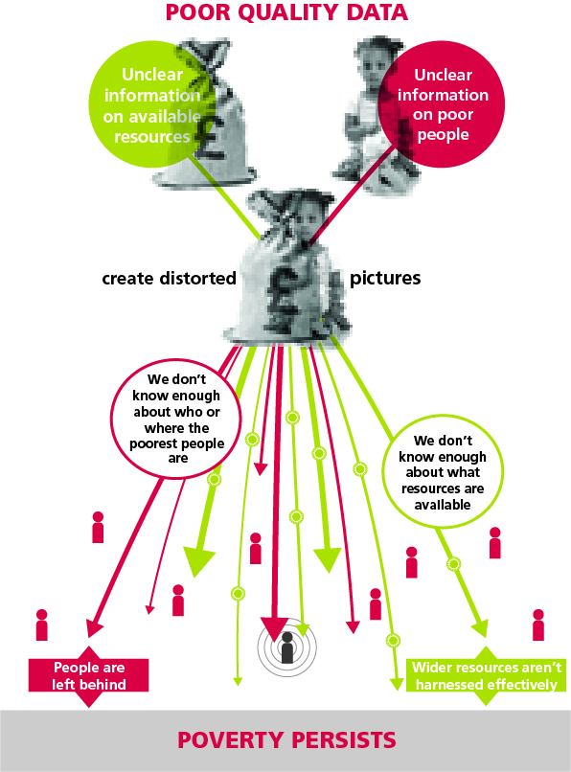Even ODA – the resource about which we know the most – is not fully understood due to the limitations of the data available. There is only partial information about the form in which ODA is delivered, the organisations who deliver it, and the places where it is spent (particularly the sub-national destinations).

Open access to information about how resources are being used enables accountability. This is true at many levels, for example citizens holding government to account or public institutions overseeing activities of the private sector. It is true at both the national and international level: transparency can empower national and international accountability mechanisms.

*Further country-level data is available on Development Initiatives’ website:*

[www.devinit.org/data-visualization/datavisualization-all-resources](http://devinit.org/data-visualization/datavisualization-all-resources/)

## Contact:

Andrew Palmer, Senior Engagement and Advocacy Adviser, DI New York Office

T: +1 (0) 212 687 4307, E: [andrew.palmer@devinit.org](mailto:andrew.palmer@devinit.org)

Tim Strawson, Senior Analyst, DI Bristol Office

T: +44 (0) 1179 272 505, E: [tim.strawson@devinit.org](mailto:tim.strawson@devinit.org) www.devinit.org